Practicing Query Language in Codio  
DAD 220 Intro to Struct Database

Sergio Mateos

Southern New Hampshire University

1. Create a new database.
   1. Create database last_name_here.

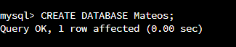

* 1. Show databases.

* 1. Use last_name_here.

1. Create a table.
   1. Create table tb2(user_idVARCHAR(50));

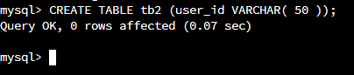

* 1. Show tables.

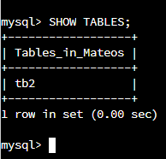

* 1. Describe tb2.

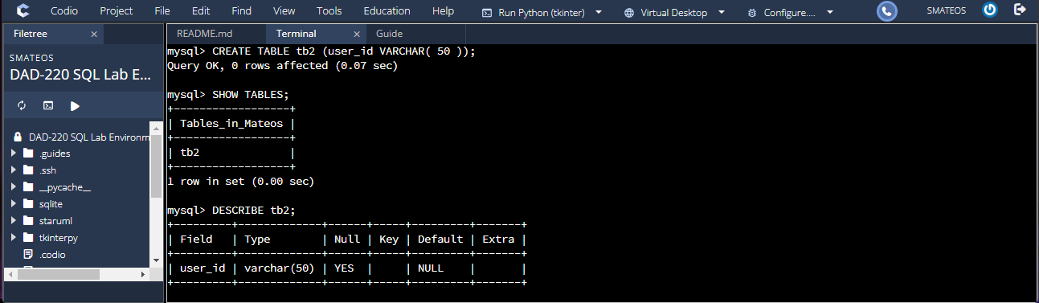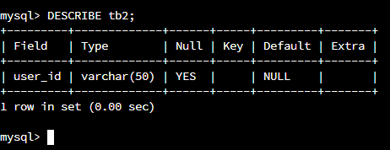

1. Add a second field into the table and describe it.
   1. alter table tb2 add newfield VARCHAR(25).

* 1. Describe tb2.

